Chapter 9, Solution 18.

- 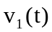 = 60 cos(t + 15)

- 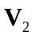 = 6 + j8 = 1053.13
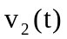 = 10 cos(40t + 53.13)

- 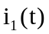 = 2.8 cos(377t – /3)

- 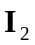 = -0.5 – j1.2 = 1.3247.4
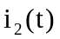 = 1.3 cos(10³t + 247.4)

